Functional Text Practice
Objective: Students will follow the directions to create a Harrier paper airplane.
Directions: Follow the directions precisely in order to complete your paper airplane.
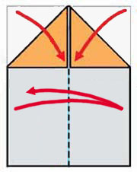  Step 1 | 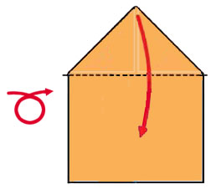  Step 2 | Step 1  Start with an 8 1/2"x11" paper or download the patterened sheet and cut off the boundary part. With patterned side down, fold paper in half vertically, then unfold.  Fold the top corners inward to the center line.  Step 2  Turn over the paper. Then, fold the triangle section down.
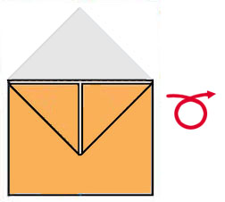  Step 3 | 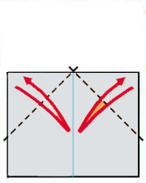  Step 4 | Step 3  After step 2, your model should look like this. Then turn over for step 4.  Step 4  Fold top corners inward to the center line and unfold.
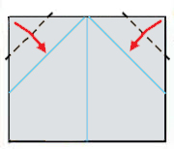  Step 5 | 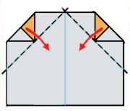  Step 6 | Step 5  Fold top corners to the crease lines.  Step 6  Fold left and right sides inward again using crease lines made in step 4.
.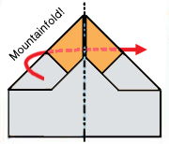  Step 7 | 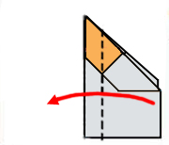  Step 8 | Step 7  Fold the model in half using a mountain-fold! Now the left side paper is behind of the right side paper. ( I hope you did not use a valley fold!)  Step 8  Note the fold line is parallel to the vertical fuselage. Fold down the wing.
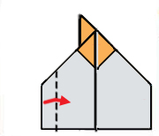  Step 9 | 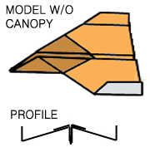  Step 10 | Step 9  Fold up the wing tip. It is about 3/4 inch from the edge. Note the folding line is strictly parallel to thefuselage.  Step 10  Repeat step 8 and 9 for the other side. The completed model should look like this.  Bend up the tail edges just a little bit for better flight. You may stop here but if you like to add a canopy then go to the next step.
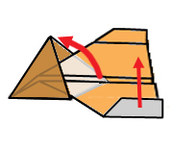  Step 11 | 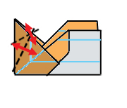  Step 12 | Step 11  Pull out the diamond shape part from the fuselage. Fold paper in half.  Step 12  Make two crease lines as shown for later steps. The n back to the original model in step 10.
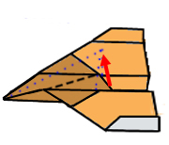  Step 13 | 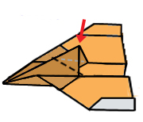  Step 14 | Step 13  Pull out the canopy section using the crease lines made in step 12. It is an inside reverse fold.  Step 14  Now another inside reverse fold for back part of the canopy. Push down the tip of the canopy part.
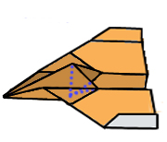  Step 15 | 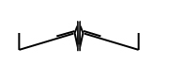  Step 16 | Step 15  Now canopy is completed.  Bend trailing edge upward for best flight.  Step 16  Adjust the creases until the model has this profile.  Note the anhedral (Negative dihedral) wing. The wing angle is downward as AV-8B Harrier jet.

